***3.7) INTRODUCTION TO SPECTROSCOPY***

**1) Spectroscopy ( Spectrum – colour , scopy – study) . It is the study of interaction of matter with electromagnetic radiation. The matter may absorb the radiation, it is absorption spectroscopy, if it emits the radiation, it is emission spectroscopy.**

**2) If the matter is an atom, it is atomic spectroscopy . If the matter is a molecule , it is molecular spectroscopy . On absorbing the energy, the matter undergoes a transition from lower to higher energy level. As the excited state is unstable, it emits energy and comes back to original ground level ( emission spectrum).**

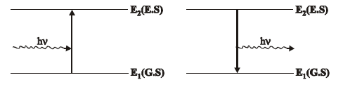

**3) Differences between atomic spectrum and molecular spectrum:**

|  |  |  |
| --- | --- | --- |
| **S.No** | **Atomic Spectrum** | **Molecular spectrum** |
| **1** | **Due to interaction of atoms and electromagnetic radiation.** | **Due to interaction of molecules and electromagnetic radiation.** |
| **2** | **It is a line spectra** | **It is a complicated spectra.** |
| **3** | **Due to the transition of electrons between electronic energy levels only.** | **Due to transition of electrons between electronic, rotational and vibrational energy levels.** |
| **4** | **Eg. Atomic Absorption spectroscopy, Flame emission spectroscopy** | **Eg. UV spectroscopy , IR spectroscopy** |

***3.7 – A) ELECTRO MAGNETIC RADIATIONS & SPECTRUM***

**1) Form of energy that is transmitted through space at high velocity is known as electromagnetic radiation. In this figure EM wave is moving along X axis. Electric field varies along Y axis and magnetic field varies along Z axis.**

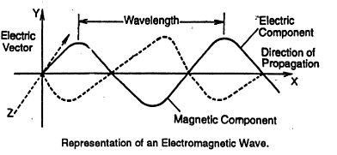

**2) Parameters involved in EM radiations:**

**a) Wavelength (λ) – Distance between two successive peaks**

**b) Frequency (γ) – Number of wavelengths passing through a point per second**

**c) Wave number ( γ̅ ) - Number of waves per cm. 1/ λ = γ̅ = γ / c**

**d) Velocity (c) – Product of Wavelength and frequency ( c = λ γ )**

***ELECTRO MAGNETIC SPECTRUM***

**The examples of electromagnetic radiations are Gamma rays, X rays, Ultraviolet rays, Visible rays, Infrared radiation, microwaves and radiowaves. When these radiations are arranged in the increasing order of their wavelengths, it is called an electromagnetic spectrum.**



***Characteristics of Electro Magnetic Spectrum:***

|  |  |  |
| --- | --- | --- |
| **Spectral region** | **Wave length range** | **Characteristics** |
| **Γ rays** | **1 – 100 pm** | **Shortest wavelength. Emitted by atomic nuclei.** |
| **X rays** | **10 – 100 nm** | **Emitted by movement of electrons closer to nuclei.** |
| **UV rays** | **100 – 400 nm** | **Since air absorbs below 189nm, only abpve 180 nm is used for chemical analysis.** |
| **Visible rays** | **400 – 750 nm** | **Human being can sense the colours.** |
| **Infra red** | **0.75 – 1000 μm** | **Due to vibration change.** |
| **Microwave** | **0.1 – 50 cm** | **Due to rotational change.** |
| **Radio wave** | **1 – 30 m** | **Due to spin change.** |

***3.7 – B) ENERGY LEVEL DIAGRAM FOR A MOLECULE***

**In a molecule, different types are energy levels are present. They are Electronic energy level, vibrational energy level and rotational energy level. The molecular spectra arises from the transitions between these energy levels.**

**According to Born – Oppenheimer approximation, total energy of the system is given by**

**EINT = ETRANS  + E ROTATIONAL  + E VIBRATION  + E ELECTRONIC**

**As, E ELECTRONIC >> E VIBRATION > E ROTATIONAL  >ETRANS,ETRANS  becomes negligible,**

**EINT = E R  + E V  + E E**

**The energy level diagram for a molecule can be represented as follows:**

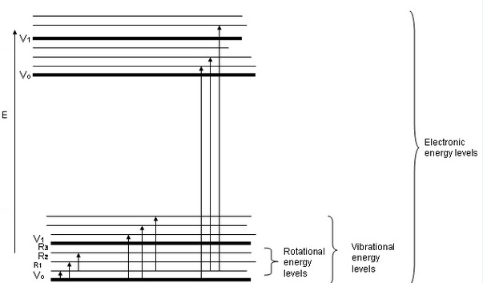

**From the diagram it is evident that**

**Each electronic level contains several vibrational sub levels.**

**Each vibrational level contains several rotational sub levels.**

**a) The energy required for exciting the molecule from one lower rotational energy level to the next higher rotational level is least. ( R1 🡪 R2)**

**b) The energy required for exciting the molecule from one lower vibrational energy level to the next higher vibrational level is more.**

**c) The energy required for exciting the molecule from one lower electronic energy level to the next higher electronic level is the maximum.**

***3.8) ABSORPTION OF RADIATION:***

**When Electromagnetic radiation passes through a matter, following changes occur.**

**1) As the photons are absorbed by matter, electronic, virbrational or rotational changes occur. After absorption, molecules get excited from Ground state to excited state. Then, they liberate the energy in the form of heat or re emit the electro magnetic radiation.**

**2) If the re-emission is fast, it is fluorescence. If it is slow, it is phosphorescence.**

**3) Sometimes, a portion of the radiation is scattered or reflected.**

**4) Sometimes, the radiation may undergo changes in polarization or orientation.**

**5) Factors affecting absorption:**

**a) Nature of absorbing molecule**

**b) Concentration of molecule ( direct relation)**

**c) Path length (direct relation**

***CONSEQUENCES OF ABSORPTION OF RADIATION***

***A) Rotational ( Microwave) Spectra:***

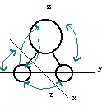**1)Rotational energy arises when the molecule rotates about an axis perpendicular to inter - nuclear axis.**

**2) Rotational spectra arise from the transitions between the rotational energy level.**

**3) It is due to the absorption of micro wave radiation. ( Far IR region).**

**4) It occurs in the spectral range of 1 – 100 cm-1 frequency.**

**5) It is shown by the molecules with permanent dipole moment. (eg) HCl, CO, H2O , NO.**

**6) The molecules without dipole moment will not show this kind of spectra. (eg) H2, Cl2, CO2**

***B) Vibrational (IR) spectra:***

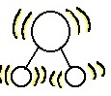

**1) It arises due to to and fro motion of molecule. i.e., stretching, contracting and bending of covalent bonds in a molecule.**

**2) It arises from transition between vibrational energy levels.**

**3) It is due to the absorption of IR radiation.**

**4) It occurs in the spectral range of 500 – 4000 cm-1 frequency.**

**5) Since it is accompanied by rotational transition, it is also known as vibrational – rotational spectra.**

**6) It is shown by the molecules which show a change in their dipole moment. (eg) CO2, H2O**

***C) Electronic (UV) spectra:***

**1) It arises due to motion of electrons with respect to the fixed nuclei .**

**2) It arises from the transition of electrons from ground state to excited state level.**

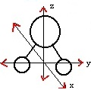

**3) It is due to the absorption of UV and visible radiations.**

**4) It occurs in the spectral range of 12500 – 25000 cm-1 frequency (Visible) and 25000 – 70000 cm-1 (UV).**

**5) Since it is accompanied by vibrational and rotational transitions, the electronic spctra are highly complex in nature.**

***3.9) UV SPECTROSCOPY : (ELECTRONIC SPECTROSCOPY)***

***Principle:***

**Their wavelength range is 100 – 400 nm. It is otherwise called as electronic transition spectroscopy , because it involves transition of electrons from ground energy state to the excited energy state. The energy is hγ = E1 - EO**

***Instrumentation:***

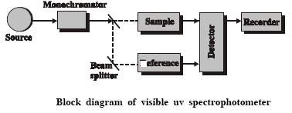

***Major components:***

**1. Source**

**2. Monochromators**

**3. Slits**

**4. Cell – sample holder - Cuvette**

**5. Detector**

**6. Amplifier**

**7. Recorder**

***1. Source:* They are used to emit uv radiation. (eg) Hydrogen lamps,**

**Deuterium lamps.**

**Requirements for a source :**

**a)The source should supply continuous radiation.**

**b) Radiation intensity should be high.**

***2. Monochromators*:**

**They filter unwanted wavelengths and colours. They allow only required radiation. They are also known as gratings or filters. They are made up of quartz.**

***3. Slits:***

**They narrow down the radiation beam. There are two slits one at entry side and another at exit area.**

***4. Cell:***

**They are used as sample holder.**

**Requirements of a cell:**

**a) They should be optically treated.**

**b) They should be chemically inert.**

**Here , two cells are used , i) sample cell ii) reference cell (only for pure solvent)**

***5.DAR assembly*:**

**Detector – Amplifier – Recorder assembly.**

**The detector converts the falling radiation into current. (eg) Barrier layer cell, photo multiplier tube , photocell detector.**

**Then the current signals are amplified , digitally recorded and displayed as uv spectrum.**

***Working of UV spectrometer***

**1. The source emits UV radiation.**

**2. The monochromator filters unwanted radiations.**

**3. Slits narrow down the beam.**

**4. Beam is sent into sample cell and reference cell.**

**5. The light coming out of reference cell is having intensity (IO) and sample cell intensity is (I). It is always IO > I.**

**6. Greater the difference, greater will be concentration of the sample, because**

**A = ε C x .**

**7. The radiation is converted to electrical energy and recorded. The recorder can give the output as a graph as shown above. This is known as ‘UV absorption specturm’.**

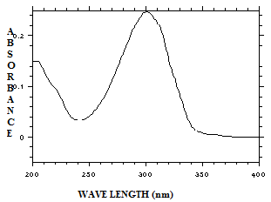

***Applications of UV spectroscopy***

**1. Quantitative analysis - knowing the concentration**

**2. Qualitative analysis – knowing the groups present**

**3. Detection of impurities – By measuring red and blue shifts**

**4. Study of tautomerism – Eg. Ethyl Aceto Acetate (EAA)**

**5. Study of reaction kinetics**

**6. Measuring dissociation constant**

**7. Determination of calcium in blood serum.**

***1. Quantitative analysis:***

**As per Beer Lambert’s law A = - log T = ε C x**

**Absorbance of different solutions of known concentrations is measured. Then the graph is plotted between absorbance Vs concentration. This is known as calibration graph. A straight line is obtained. Now, the unknown solution is taken and its absorbance is plotted along the straight line. The corresponding x axis point gives the unknown concentration.**

***2. Qualitative analysis:* By comparing with the reference standard spectrum with that of spectrum of unknown sample, we can identify a lot of organic compounds.**

***3. Detection of impurities:* Pure compounds show their characteristics bands in the UV spectrum while the presence of impurities causes red or blue shifts.**

***4. study of tautomerism***

**As they show different wavelengths , they can be easily differentiated.**

**Eg. Ethyl Aceto Acetate exists in keto and enol form which can be easily found out.**



***5. Study of reaction kinetics:* Reactants 🡪 Products**

**By studying the concentration of reactants and products, we can follow the reaction kinetics. (e.g) Secondary alcohols (on oxidation) 🡪 Ketones**

**At regular intervals, the spectrum of the reaction mixture is taken and the corresponding peaks show the % conversion of alcohols to ketones.**

***6. Dissociation constants:***

**PKa  = PH  + log [ HA ] / [ A - ]**

**We can determine the [HA] and [A-] by uv absorbance spectrum. So, the dissociation constant PKa can be determined.**

***7. Calcium in blood serum:***

**Calcium is converted into calcium oxalate and added with sulphuric acid and ceric sulphate to form a complex solution. This solution ‘s absorbance is measured at 315nm. Then by normal calibration curve technique, the concentration is known.**

***Other related topics in UV spectroscopy:***

**1. Their wavelength range is 100 – 400 nm. It is otherwise called as electronic transition spectroscopy , because it involves transition of electrons from ground energy state to the excited energy state. The energy is hγ = E1 - EO**

**2. There are 3 types of electrons are involved in UV spectroscopy .**

**a) sigma electrons ( σ ) - involved in single bond (eg) alkane**

**b) pi electrons ( П ) - involved in double bond (eg) alkenes**

**c) non bonding (n) electrons – present in hetero aton (eg) Ketone**

**(e.g) Formaldehyde - HCHO**

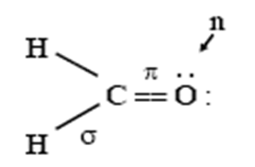

**3. The energy level is in the order n🡪 П* < П 🡪 П* < n 🡪 σ* << σ 🡪 σ\***

**σ 🡪 σ* is seen in alkane.. П 🡪 П* is seen in alkene.. n🡪 П*  and n 🡪 σ* are seen in ketones. Out of these transitions, n🡪 П*  has least energy and hence it is forbidden transition.**

**Energy level diagram:**

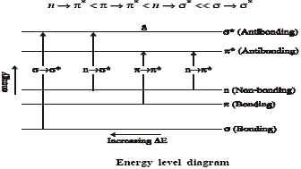

**4. The double bond present in the compound is responsible for the colour of the compound. They are called as ‘*chromophore’*. Some atoms will not give any absorption when it is alone, but when attached with the chromophores, they will increase the colour. They are known as ‘*auxochromes*’.**

**E.g) CH2 = CH2, here the double bond is chromophore. I**

**CH2 = CH. Cl , here the Cl is auxochrome. N**

**Thus they can make some changes in the spectrum position. T**

**This process is known as shift. They are mainly four types of shift. E**

**Increase in wavelength is called *Red shift* (Bathochromic shift). N**

**Decrease in wavelength is called *Blue shift* (Hypsochromic shift). S**

**Increase in intensity of the colour is called *Hyperchromic shift* I**

**Decrease in intensity of the colour is called *hypochromic shift. T***

Y WA.LENGTH

**5. Differences between Chromophore and auxochrome**

|  |  |  |
| --- | --- | --- |
| **No** | **CHROMOPHORE** | **AUXOCHROME** |
| **1** | **This group is responsible for the colour of the compound.** | **It does not impart colour, but when conjugate to chromophore, produces colour.** |
| **2** | **It does not form salt.** | **It forms salt.** |
| **3** | **It contains atleast one multiple bond.** | **It contains lone pair of electron.** |
| **4** | **Eg. Ethylene, acetylene, Carbonyls, azo compounds** | **Eg. Amino group, Chloro group, Cyano group, Hydroxyl group** |

**Problem:**

**1.Which of the following compounds absorb UV tadiation?**

**Heptane , Benzene, Buta diene, Water, Heptene, Chloro hexane, Ethanol, Acetone,**

**n-butyl amine, Acetone, ethylene, Nitrobenzene, Benzoic acid.**

**Heptane No double bond - no absorption**

**Benzene double bond – absorption happens**

**Buta diene double bond – absorption happens**

**Water No double bond – No absorption**

**Heptene double bond – absorption happens**

**Chloro hexane no double bond – no absorption**

**Ethanol no double bond – no absorption**

**n- butyl amine no double bond – no absorption**

**Acetone double bond – absorption happens**

**Ethylene double bond – absorption happens**

**Nitrobenzene double bond absorption happens**

**Benzoic acid double bond absorption happens**

**Problem 2**



**Greater the extent of conjucation, greater will be the value of λ max in UV spectrum. Hence, the compound II ( Having more double bond) have greater λmax than that of compound I.**

**Problem 3**

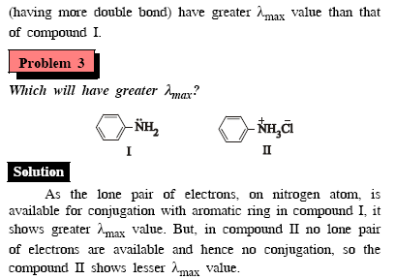**As the lone pair of electrons on N atom is available for conjugation with benzene ring in I , it shows greater λmax  . But, in II no lone pair of electrons are available and hence no conjugation. It has lower λmax value only.**

***3.10) IR SPECTROSCOPY***

***Principle:***

**IR spectroscopy is otherwise known as vibrational spectroscopy. Because, the absorption of energy causes transitions at vibrational levels.**

**The wave number range is 12,500 cm-1 to 50 cm-1.**

**NEAR**

**IR IR FAR**

**IR**

**12500 4000 667 50 cm-1(wave number )**

**Group frequency zone Finger print zone**

**( 4000 – 1430 cm-1) ( 1400 – 700cm-1)**

**No two finger prints of two human beings can be the same. Similarly, in the IR region of 1400 – 700 cm-1 , no two compounds can have the same absorption frequency. So this zone is called as ‘Finger print zone’.**

***Selection rule for IR spectroscopy:***

**a) Molecule must show change in di pole moment.**

**b) For linear molecule number of vibration modes = (3n – 5)**

**c) For non-linear molecule , number of vibration modes = (3n -6) ,**

**where , n= number of atoms**

***Working and instrumentation of IR spectroscopy***

***Major components*:**

**1. Source**

**2. Monochromators**

**3. Slits**

**4. Cell**

**5. Detector**

**6. Amplifier**

**7. Recorder**

**1. Source: They are used to emit IR radiation. (eg) Nichrome wire, Nernst glower (Zr, Th, Ce oxides), Globar ( Silicon carbide rod) – They are heated at 1200 – 2000oC to produce IR radiation.**

**Requirements for a source :**

**a)The source should supply continuous radiation.**

**b) Radiation intensity should be high.**

**2. Monochromators:**

**They filter unwanted wavelengths and colours. They allow only required radiation. They are also known as gratings or filters.**

**Common Prism materials include NaCl, KBr, LiF.**

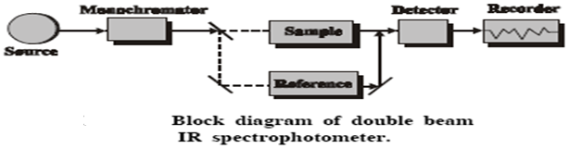

**3. Slits:**

**They narrow down the radiation beam. There are two slits one at entry side and another at exit area.**

**4. Cell:**

**They are used as sample holder.**

**Requirements of a cell:**

**a) They should be optically treated.**

**b) They should be chemically inert.**

**Here , two cells are used , i) sample cell ii) reference cell (only for pure solvent)**

**5.DAR assembly: (Detector – Amplifier – Recorder assembly.)**

**The detector converts the falling radiation into current signals.**

**Two types of detectors are employed in IR spectroscopy.**

**a) Selective Detectors – Their response is directly proportional to the wavelength of incident radiation. (eg)Photocells, Infrared phosphors.**

**b) Non selective detectors – Independent of the wavelength of incident radiation.**

**Eg) Thermocouples, Pneumatic cell, Bolometers**

**Then the current signals are amplified , digitally recorded and displayed as IR spectrum.**

***Working of IR spectrometer***

**1. The source emits IR radiation.**

**2. The monochromator filters unwanted radiations.**

**3. Slits narrow down the beam.**

**4. Beam is sent into sample cell and reference cell.**

**5. The light coming out of reference cell is having intensity (IO) and sample cell intensity is (I). It is always IO > I.**

**6. Greater the difference, greater will be concentration of the sample,**

**Because A = ε C x .**

**7. The radiation is converted to electrical energy and recorded. The recorder can give the output as a graph of transmittance Vs wavenumber. This is known as ‘IR absorption specturm’. It can be represented as**

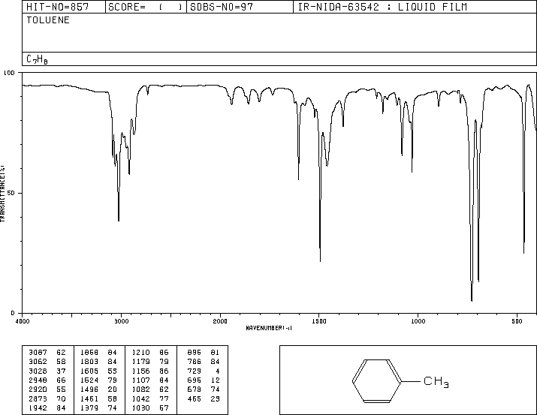

***Applications of IR Spectroscopy***

**1. Linearity and non- linearity**

**2. Nature of Crystalline structure or amorphous**

**3. Finger print region**

**4. Force constant calculation**

**5. Reaction kinetics**

**6. Dissociation constant**

**7. Purity of a substance**

**8. qualitative analysis**

**1. Linearity and non- linearity:**

**It is used to find whether a molecule is linear or non-linear. (e.g) IR spectra of NO2 gives 3 vibrational modes. According to the rule,**

**a) For non – linear molecule , (3n – 6 ) = (9 – 6) = 3 modes,**

**b) For linear molecule , (3n – 5) = ( 9 – 5) = 4 modes.**

**As the spectrum shows 3 modes , it is clear that the molecule is non – linear.**

**2. Nature of crystalline structure:**

**Using IR spectra , the physical structures like crystalline nature or amorphous can be determined.**

**(e.g) Nylon 6,6 - crystalline – IR band at 934 cm-1**

**- amorphous – IR band at 1238cm-1**

**3. Finger print region:**

**No two finger prints of two human beings can be the same. Similarly, in the IR region of 1400 – 700 cm-1 , no two compounds can have the same absorption frequency. So this zone is called as ‘Finger print zone’. It is used to find out different functional group.**

**4. Force constant calculation:**

**The force constant (k) measures the force required to deform a bond . By IR studies, it is proved that HF has a stronger bond than HCl.**

**5. Study of reaction kinetics:**

**Reactants 🡪 Products**

**By studying the concentration of reactants and products, we can follow the reaction kinetics.**

**(e.g) Secondary alcohols R2 – CH - OH (on oxidation) 🡪 R2 – C=O Ketones**

**(3570 cm-1) (1725cm-1)**

**At regular intervals, the IR spectrum of the reaction mixture is taken and the corresponding peaks show the % conversion of alcohols to ketones.**

**6. Dissociation constants:**

**PKa  = PH  + log [ HA ]**

**-----------**

**[ A - ]**

**We can determine the [HA] and [A-] by IR absorbance spectrum. So, the dissociation constant PKa  can be determined.**

**7. Detection of impurities:**

**Pure compounds show their sharp spectrum while impure material have broadened spectrum.**

**8. Qualitative analysis:**

**By comparing with the reference standard spectrum with that of IR spectrum of unknown sample, characterization and identification of aromatic compounds can be done.**

***MODES OF VIBRATIONS INVOLVED IN IR SPECTROSCOPY:***

**Types of vibration modes:**

|  |  |  |  |  |
| --- | --- | --- | --- | --- |
| **S.No** | **Mode** | **Bond angle** | **Bond distance** | **Types** |
| **1** | **Stretching** | **Constant** | **Changes** | **Symmetric**  **(equal on both sides)**  **Asymmetric**  **(Unequal)** |
| **2** | **Bending** | **Changes** | **Constant** | **In plane – Scissoring and Rocking**  **(with in the plane)**  **Out plane – Twisting and Wagging**  **(goes outward / inward of plane)** |

**For linear molecule number of vibration modes = (3n – 5)**

**For non-linear molecule , number of vibration modes = (3n -6) ,**

**where , n= number of atoms.**

**Eg) 1.water molecule, H2O , n=3 and non linear**

**(3n – 6) = (9 – 6) = 3 vibrations are possible.**

**i) Symmetric stretching ( 3652cm-1)**

**ii) Asymmetric stretching (3756cm-1)**

**iii) bending ( 1596 cm-1)**





**Eg 2) Carbon – di – oxide , CO2 , n = 3 and linear molecule.**

**As per theory , there should be (3n – 5) = (9 – 5) = 4 vibrations must be there.**

**But in practice , only two vibrations modes are observed.**

**Reason:**

**Theoretically, it can have four modes.**

**i) Symmetric stretching ii) Asymmetric stretching**

**iii) In plane bending iv) out plane bending**

**Out of the four (iii) and (iv) are overlapping at same frequency at 666cm-1.**

**Case (i), symmetric stretching does not involve any change in dipole moment, which is essential for IR activity.**

**So, only asymmetric stretching and one bending modes are possible for CO2.**





**Eg 3) CalculateFundamental IR vibrations for the following**

**i) Linear C2H6  (Ethane ) ii) Non – linear C6H6 ( Benzene) iii) Linear HCl**

**i)For ethane n = 8, so Linear (3n-5) = (24 – 5) = 19 modes of vibrations.**

**ii)For benzene, n=12, Non linear (3n-6) = (36 – 6) = 30 modes of vibrations.**

**iii)For HCl , n= 2, linear (3n-5) = (6-5) = 1 mode of vibration.**